**Zomato Dashboard**

Zomato is one of the leading food delivery platforms in the world, offering a variety of restaurant choices, cuisines, and delivery options to its customers. I have prepared robust analytical project to monitor its operational metrics, identify trends and make make data driven decisions.

**Zomato Power BI Project**

**Key Objective:**

* Order Analysis
* User Preference
* Sales Analysis
* City wise Analysis

I have used different types for DAX queries to create measures for different calculations.

Create VAR in DAX to categorise the quantity sold in Top 10 or 20 cities.

Create bookmarks for page navigator through project.

**Title Page**

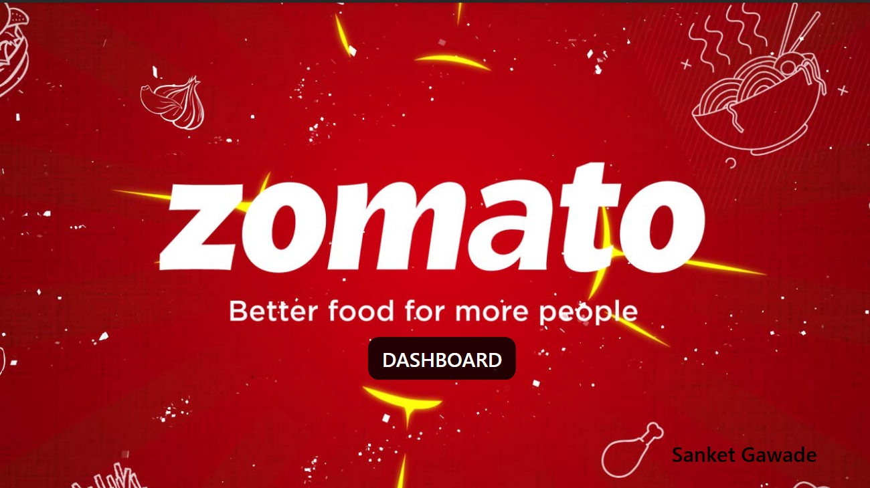

**Main Dashboard**

* This slide contains Total sales amount, Quantity sold, Average Ratings and No of Orders.
* I have also bifurcate food in veg – non veg category with their respective ratings. This values contains both Sales value and Quantity sold with Filter.
* Line graph shows Sales by year
* Special DAX formula is created to show different Top quantity sold city wise.

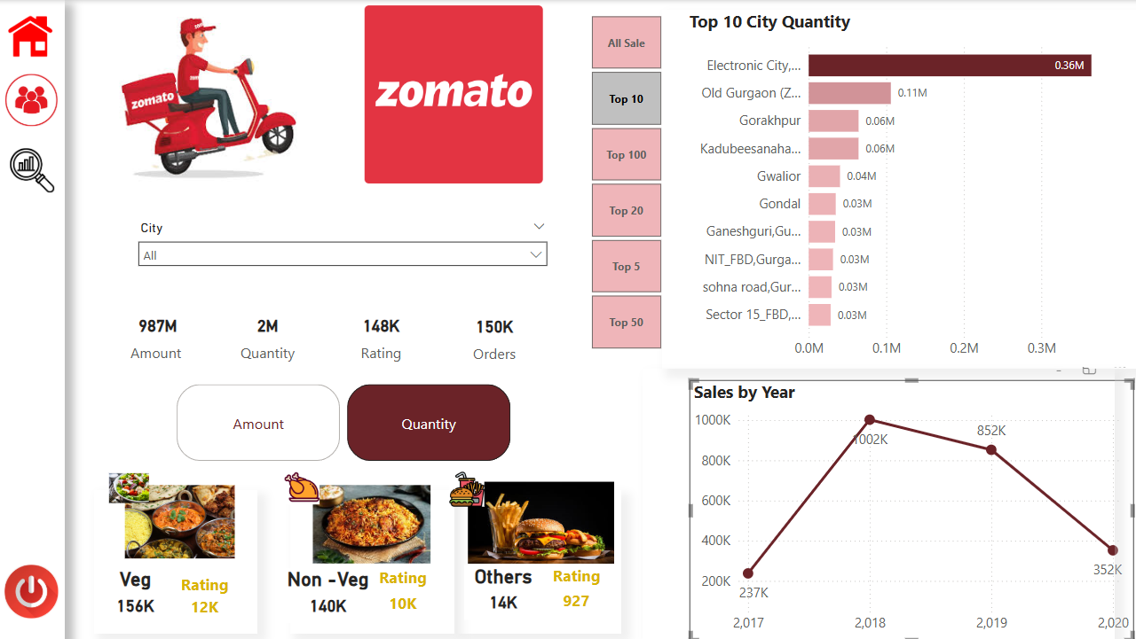

**Customer Overview**

* Slide shows no of Active users, Total number of Ratings, Total orders with City wise filter
* Age wise users
* Gain and Lost users according to last users with Gender wise bifurcation.

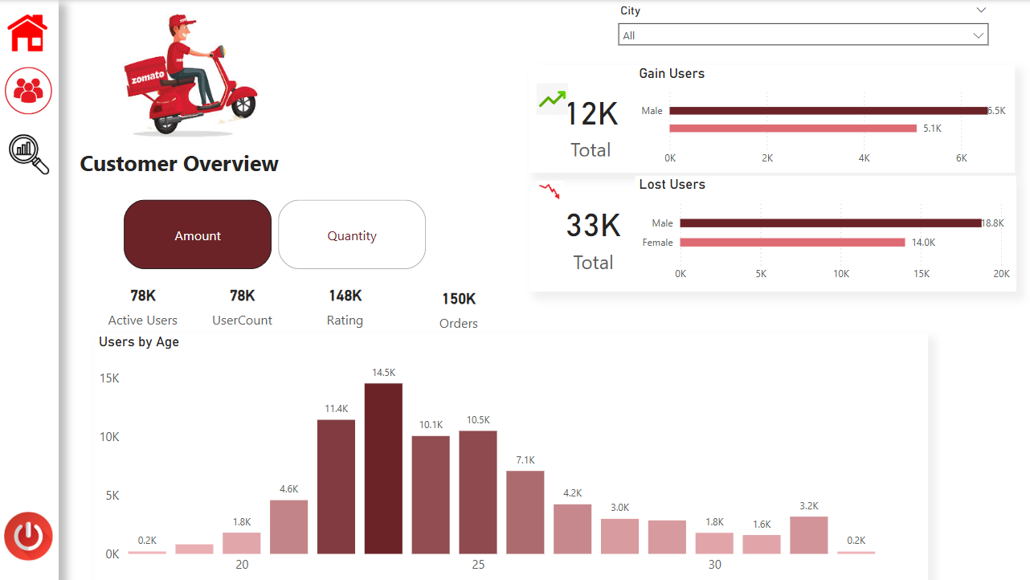

**City Performance**

* Slide shows city performance with Total sales amount, Quanity sold, Rating and Total ordes
* Table is added to show exact value of Sales, Order, Gain user and Lost users.

